**Quality – Assurance**

**[Corporation Surety to State for Livestock Breeds Improvement]**

**Govt. of India CMU Team evaluated as B grade**

**[Govt. of India instructed that state having A& B graded will get financial help from GoI]**

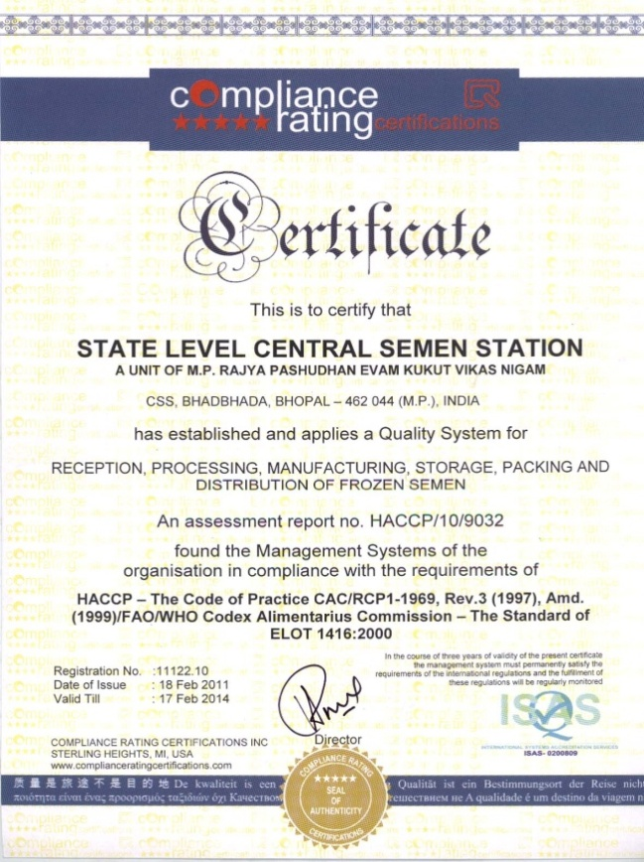

Compliance Rating Certificate HACCP Certified by INC, MI USA

Date of issue 19.02.2011 Valid till 17.02.2014

**Institutional Excellence**

**Bull Mother Farm, Bhadbhada, Bhopal**

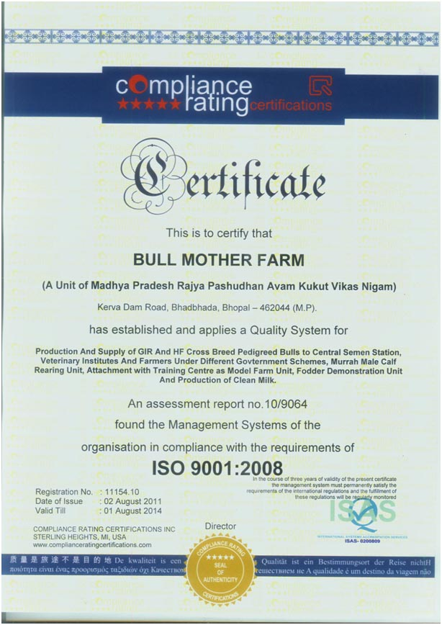

ISO 9001-2008 Certificate by Compliance Rating Certification

INC, MI USA date of issue 02.08.2011 valid till 0108.2014

**Institutional Excellence**

**Regional Semen Bank Rewa**

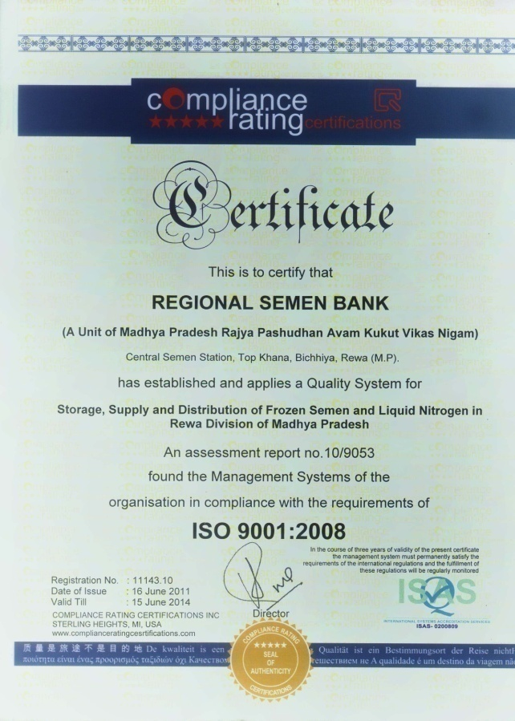

ISO 9001-2008 Certificate by Compliance Rating Certification,

INC, MI USA date of issue 16.06.2011 valid till 15.02.2014

**MoU with IGNOU & MPLPDC for Training & Certificate Programme**

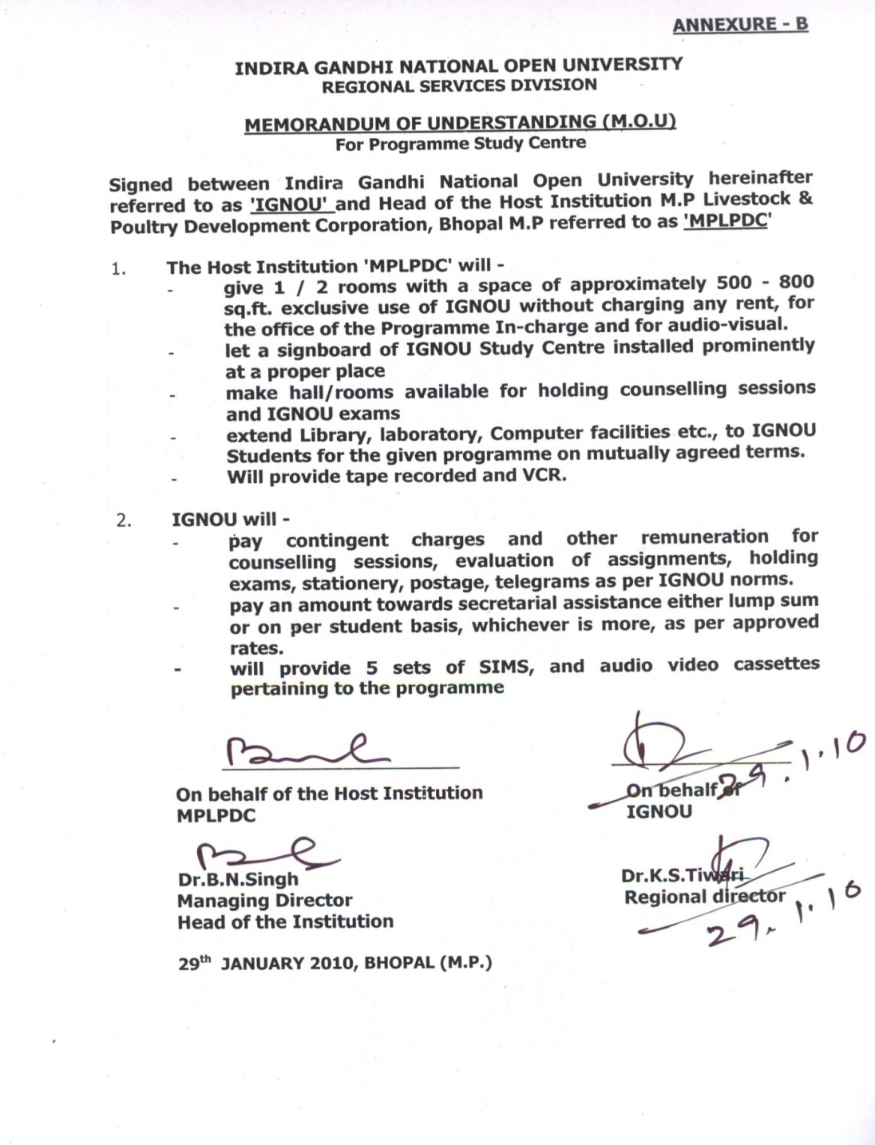

**M. P. State Livestock & Poultry Development Corporation, Bhopal**

M. P. State Livestock & Poultry Development Corporation established on 19th Nov. 1982 under Govt. of M. P. Act. 37 (1982). The main object of the Corporation is to ***improve the breed of Cow, Buffaloe, Goat, pig and poultry in the state, to generate employment*** in state and to increase the income levels of farmers.

**01. Share Capital –**

Authorised - Rs. 200.00 Lakhs.

Paid up - Rs. 118.23 Lakhs.

**02. Vision and Object –**

**(A) Vision –**

1. To improve, enrich and enhance livestock & Poultry production in the state and increase the income levels of farmers involved in animal husbandry, particularly women.
2. To make M.P. as a Goat State.

**(B) Mission of the Organization –**

|  |  |  |
| --- | --- | --- |
| * Towards Consumer/Beneficiaries | **i.** | Transparency & fair dealing in the interest of consumer / Beneficiaries. |
|  | **ii.** | To improve socio-economic status of Livestock owners. |
|  | **iii.** | To generate rural employment through animal husbandry activity. |
|  | **iv.** | To provide more milk & meat to consumers through breed improvement. |
| * Towards employees | **i.** | Transparency in Corporation activity. |
|  | **ii.** | To assist employees in their carrier development through training and efficient HR development practices |
| * Towards Government | **i.** | Contribute in GDP of state through Animal Husbandry. |
|  | **ii.** | To strengthen internal financial resources of the Corporation to become self sufficient. |

**03. Objectives of the Organisation (Short term & Long term) –**

1. Supply of genetically superior animals to beneficiaries under different Govt. schemes and to increase the income of farmers. **[Long Term & Short Term]**
2. Implementation of breed improvement programme in the state. **[Long Term & Short Term]**
3. To increase the milk production in the state through NPCBB.  **[Long Term & Short Term]**
4. Implementation of Livestock Insurance Scheme (State Govt. & GoI). **[Long Term & Short Term]**
5. Production and marketing of poultry & cattle feed. **[Long Term & Short]**
6. Rearing of genetically superior murra buffaloes calves at B M F, Bhopal. **[Long Term & Short Term]**
7. To educate the farmer for better livestock management practices. **[Long Term & Short Term]**
8. To promote breed improvement of draught & milch animals.  **[Long Term & Short Term]**
9. Establishment of ETT Lab. at PSS, Bhadbhada, Bhopal. **[Long Term & Short Term]**
10. Establishment of 4 LN2 Plant in Madhya Pradesh. **[Long Term & Short Term]**
11. Establishment of Automatic & mechanized dairy at B M F under “National Mission for Protien suppliment” (NMPS) R.K.V.Y. **[Long Term & Short Term]**
12. Artificial Insemination training for beneficiaries (Gosewak & Animal breeders)**[Short Term]**
13. Establishment of Animal breeding & Goat breeding farm at Kiratpur (Itarsi). **[Long Term]**

1. Conducting certificate training cource for Poultry & Livestock trainees. **[Long Term]**

**04. Formation of Project Cell –**

(Established in May 2009 onwards).

1. Preparation of Detail Project Report for establishment of large Dairy, Goatary, Poultry and Piggery project in M.P..
2. Assistance for sanctioning loan from Banks and NABARD.
3. Assistance in marketing in India and export.
4. Timely implementation of sanctioned projects.

**05. Action Plan & Activities Undertaken by the Organisation to Achieve above Objectives -**

# Strategies for Achieving Objectives : -

# 

1. Target of Corporation is divided among the district for each month. Management reviews the progress of each district every month on the basis of monthly reports.
2. Executive of District, who gives highest profit to Corporation will get award of cash prize and certificate.
3. Major component of turnover of the Corporation is from supply of genetically superior livestock under different Govt. schemes. Executive officer of the Corporation is in regular contact with Collectors and CEO of Zilla Panchayat of the districts for sanction of Govt. sponsored scheme.
4. The registered livestock supplier of the Corporation who supplies highest number of animals will be awarded cash prize & certificate.
5. Preparation of different projects for Animal Husbandry activities & its approval from GoI / state / Deptt. / Zila Panchayat & timely implementation of sanctioned projects.
6. Production of Frozen Semen at Central Semen Station, Bhadbhada, Bhopal as the requirement of breed improvement in the state.
7. Production of liquid nitrogen gas for cold chain in the state.
8. Establishment of ETT Lab., Bhopal for producing high genetic superior breed Bull & Dams.
9. Rearing of Murrah male calf & supply to livestock owners for breed improvement.

**MoU Year 2013-14**

**[A] Commercial / Financial –**

**¼Total Weight age 43%)**

|  |  |  |  |  |  |  |  |  |  |  |  |  |  |  |  |  |  |
| --- | --- | --- | --- | --- | --- | --- | --- | --- | --- | --- | --- | --- | --- | --- | --- | --- | --- |
| **Particular** | | **Target**  **2010-11** | | **Actual**  **2010-11** | | **Target**  **2011-12** | | **Actual**  **2011-12** | | **Target**  **2012-13** | | **Actual**  **2012-13** | | **Target**  **2013-14** | | **Corresponding Objective** | **Weight age** |
| **Phy.** | **Fin.**  **(`Lakh)** | **Phy.** | **Fin.**  **(`Lakh)** | **Phy.** | **Fin.**  **(`Lakh)** | **Phy.** | **Fin.**  **(`Lakh)** | **Phy.** | **Fin.**  **(`Lakh)** | **Phy.** | **Fin.**  **(`Lakh)** | **Phy.** | **Fin.**  **(`Lakh)** |
| 1. **Business –** | | | | | | | | | | | | | | | | | |
| Supply of Genetically Superior Livestock including Bullock Pair | 20000 | | 3200.00 | 13525 | 2035.63 | 20000 | 3400.00 | 14330 | 2236.07 | 18000 | 3150 | 14505 | 2954.21 | 18000 | 3300.00 | Employment generation | 5 |
| Breed Improvement  (Supply of Male) Cattle, Buffaloes, Goat, Pig | 12427 | | 915.00 | 10754 | 808.00 | 11000 | 700.00 | 12236 | 786.53 | 9091 | 800.00 | 9934 | 706.87 | 10800 | 850.00 | Making livestock farming more profitable | 5 |
| Sale of feed  (Poultry, Cattle & Goat ) | - | | 200.00  (1800 MT) | - | 96.00 | - | 200.00 | - | 107.41 | - | 250 | 410 MT | 64.76 | 2000 MT | 350.00 | Supply of balance feed at competitive price | 5 |
| Sale of LN2 | - | | 154.00 | 10.10 Lakh liter | 158.86 | - | 160.00 | - | 162.26 | - | 175 | 5.74 Lakh Liter | 193.00 | 6.00 Lakh Liter | 200.00 | Breed improvement of cattle & buffaloes | 1 |
| Production of frozen semen | 10.50 Lakh | | 126.00 | - | 125.31 | - | 135.00 | - | 139.00 | - | 150 | 12.33 Lakh Straw | 188.25 | 15.00 Lakh Straw | 300.00 | Breed improvement of cattle & buffaloes | 1 |

|  |  |  |  |  |  |  |  |  |  |  |  |  |  |  |  |  |
| --- | --- | --- | --- | --- | --- | --- | --- | --- | --- | --- | --- | --- | --- | --- | --- | --- |
| **Particular** | **Target**  **2010-11** | | **Actual**  **2010-11** | | **Target**  **2011-12** | | **Actual**  **2011-12** | | **Target**  **2012-13** | | **Actual**  **2012-13** | | **Target**  **2013-14** | | **Corresponding Objective** | **Weight age** |
| **P.** | **Fin.**  **(`Lakh)** | **P.** | **Fin.**  **(`Lakh)** | **P.** | **Fin.**  **(`Lakh)** | **P.** | **Fin.**  **(`Lakh)** | **P.** | **Fin.**  **(`Lakh)** | **P.** | **Fin.**  **(`Lakh)** | **P.** | **Fin.**  **(`Lakh)** |
| N. P. C. B. B., Cattle Breeding farm, Kiratpur & BMF Bhadbhada, Bhopal | - | 660.00 | - | 670.00 | - | 680.00 | - | 1245.78 | - | 800.00 | - | 799.24 | - | 1728.00 | Production of genetically superior male for breeding | 1 |
| Bundelkhand Special package | - | 190.00 | - | 92.32 | - | 250.00 | - | 621.64 | - | 600.00 | 1447 | 533.00 | 1388  Murrah  +  Goat Unit  3800 | 972.00 | Supply of genetically superior male for breeding | 1 |
| Livestock Insurance Scheme | - | 350.00ku 82kkkj gsrq kZRed nj ij iznk; gk;rk djukA | - | 257.23 | - | 360.00 | - | 139.02* | - | 150.00 | 23538 | 198.44 | 41200 | 400.00 | protect the Farmers from losses due to death of animals | 1 |
| **Total** | **-** | **5795.00** | **-** | **4243.35** | **-** | **5885.00** | **-** | **5437.86** | **-** | **6075.00** | **-** | **5637.77** | **-** | **8100.00** | **-** |  |

|  |  |  |  |  |  |  |  |  |  |  |
| --- | --- | --- | --- | --- | --- | --- | --- | --- | --- | --- |
| **S. No.** | **Particular** | **Target**  **2010-11 (`Lakh)** | **Actual**  **2010-11 (`Lakh)** | **Target**  **2011-12 (`Lakh)** | **Actual**  **2011-12 (`Lakh)** | **Target**  **2012-13 (`Lakh)** | **Actual**  **2012-13 (`Lakh)** | **Target**  **2013-14**  **(`Lakh)** | **Corre sponding Obj.** | **Weightage** |
| 1 | Turn Over | 5795.00 | 3121.84 | 5885.00 | 4339.55 | 6075.00 | 4495.24  (Provisional) | 8100.00 | - | 7 |
| 2 | Profit Before Tax | 35.00 | (-) 58.96 | 60.00 | 74.75 | 65.00 | 80.00  (Provisional) | 100.00 | - | 5 |
| 3 | Profit after Tax | - | - | 25.00 | 46.05 | 30.00 | 45.00  (Provisional) | 70.00 | - | 5 |
| 4 | Repayment of Govt. loan  (if any) | - | - | Nil | - | - | - | - | - | - |
| 5 | Payment of loan interest of Govt. of M.P. (if any) | - | - | Nil | - | - | - | - | - | - |
| 6 | Payment of dividend to Govt. of M.P. | 06.00 | - | 6.00 | 6.27  (Provisional | 2.00 * | Nil | 1.00 *  (Approximate) | - | - |
| 7 | Repayment / refund of share capital of Govt. of M.P. | - | - | Nil | - | - | - | - | - | - |
| 8 | Payment of guarantee fee to Govt. of M.P. | - | - | Not pending in accounts | - | - | - | - | - | - |
| 9 | Repayment of Bank Loan | - | - | Nil | - | - | - | - | - | - |
| 10 | Gross Losses cumulative | - | (-) 586.77 | (-) 561.77 | (-) 540.72 | (-) 510.72 | (-) 495.72  (Provisional) | (-) 425.72  (Approximate) | - | - |
| 11 | Recovery | - | - | Pending amount of Rs. 170.00 Lakh will recover from Vety Dept. against supplyied animals pending amount of Rs. 170.00 Lakh | Rs. 150 Lakh pending amount recovered from Vety. Dept. | Pending amount of Rs. 3 Crore will recover from Vety Dept. against supplyied animals pending amount of ` 3 Crore | Rs. 225 Lakh pending amount recovered from Vety. Dept. | Demand as on 01.04.13 is Rs. 688 Lakh Only out of this 70% decresed will be recovered from Vety Dept. & pending AI Fee amount of Rs. 593.91 Lakh as on 01.04.13 also will be recovered from Vety. Dept. | - | 6 |

* Target has been kept low since the first priority is to liquidate accumulate loses and because corporation has turned into the profit making in 2011-12.

**Corporation’s Turn Over Last Six Years**

**Proposed**

**Year**

**Corporation’s Profit & Loss Chart Last Five Years (Rs. in Lakh)**

**Farmers Training in Animal Husbandry Sector**

**Proposed**

**Year**

**(B) Developmental / Promotional -**

**¼ Weight age 31%)**

|  |  |  |  |  |  |  |  |  |  |  |  |  |  |  |  |  |
| --- | --- | --- | --- | --- | --- | --- | --- | --- | --- | --- | --- | --- | --- | --- | --- | --- |
| **Particular** | **Target**  **2010-11 (`Lakh)** | | **Actual**  **2010-11 (`Lakh)** | | **Target**  **2011-12 (`Lakh)** | | **Actual**  **2011-12 (`Lakh)** | | **Target**  **2012-13** | | **Actual**  **2012-13** | | **Target**  **2013-14** | | **Corresponding Obj.** | **Weight age** |
| **Phy.** | **Fin.**  **(`Lakh)** | **Phy.** | **Fin.**  **(`Lakh)** | **Phy.** | **Fin.**  **(`Lakh)** | **Phy.** | **Fin.**  **(`Lakh)** | **Phy.** | **Fin.**  **(`Lakh)** | **Phy.** | **Fin.**  **(`Lakh)** | **Phy.** | **Fin.**  **(` Lakh)** |
| 1. To organize Cattle Fair | 2000 | 18.00 | 2250 | 20.25 | 2400 | 21.60 | 1489 | 13.40 | 1500 | 13.50 | 1456 | 13.30 | 1000 | 20.00 | Supply of animals | 3 |
| 2. To Participate in Fairs / Exhibitions | 2 | 1.00 | 2 | 1.00 | 2 | 01.00 | 2 | 01.00 | 2 | 01.00 | 2 | 10.00 | 5 | 25.00 | Farmers awareness | 5 |
| 3. Training of Farmers in different categories of Livestock & Poultry including IGNOU also | 7000 | 24.50 | 7600 (786 Only from IGNOU) | 26.60 | 9000 | 31.50 | 9200 (1143 Only from IGNOU) | 32.20 | 9500 | 33.25 | 1990 (1147 Only from IGNOU) | 34.20 | 4000 (Only training atleast 5 days duration) | 35.00 | Farmers awareness | 6 |
| (A) Preparation & distribution of Pamphlet, folder to farmer | 3000 | 3.00 | 3000 | 3.00 | - | - | - | - | 5000 | 1.50 * | 1.58 lakh Animal breeder calendar, 50000 pamphlet, 10000 folder, flex 3000 distributed to livestock owners &books printed Pashu Palan Evam Prabhandhan Marg Darshika | 26.10 | 1.50 Lakh  Animal Husbandry calander which should be made more informative folder & 1 documentry film 60000 folder 30000 booklet | 60.00 | - | 4 |

* Fund received from State Govt./Central Govt. under publication head.

|  |  |  |  |  |  |  |  |  |  |  |  |  |  |  |  |  |
| --- | --- | --- | --- | --- | --- | --- | --- | --- | --- | --- | --- | --- | --- | --- | --- | --- |
| **Particular** | **Target**  **2010-11 (`Lakh)** | | **Actual**  **2010-11 (`Lakh)** | | **Target**  **2011-12 (`Lakh)** | | **Actual**  **2011-12 (`Lakh)** | | **Target**  **2012-13** | | **Actual**  **2012-13** | | **Target**  **2013-14** | | **Corresponding Obj.** | **Weight age** |
| **Phy.** | **Fin.**  **(`Lakh)** | **Phy.** | **Fin.**  **(`Lakh)** | **Phy.** | **Fin.**  **(`Lakh)** | **Phy.** | **Fin.**  **(`Lakh)** | **Phy.** | **Fin.**  **(`Lakh)** | **Phy.** | **Fin.**  **(`Lakh)** | **Phy.** | **Fin.**  **(` Lakh)** |
| 4..Project Implementation  (within time limits) | 8 | 2070.00 | Imp. the scheme | - | - | - | - | - | i. Establishment of ETT Lab.  ii. Establishment of LN2 Plant  iii. Implementation of (NMPS) Sub-scheme of R.K.V.Y. at BMF Bhadbhada Bhopal (strengthening & enhancement of established farm)  iv. NMPS, Bull mother farm  (Establishment of modern dairy farm)  v. Establishment of Murrah Buffaloe breeding farm under NMPS at kiratpur farm | 75.00  259.00  256.00  411.00  338.00  749.00  778.00 | Establishment of 1 ETT Lab.  Establishment of one LN2 Plant    Direction of animal breeding farm Kiratpur, & land development | 75.00  259.00  256.00  411.00  338.00  749.00  778.00 | i. Strengthening of ETT building & equipment for ETT Lab.  ii. Establishment of two LN2 Plant  iv. NMPS, Bull mother farm  (Establishment of modern dairy farm)  v. Establishment of Murrah Buffaloe breeding farm under NMPS at kiratpur farm  vi. 1300 Poulrry & Animal Husbandry certificate cources  vii. Rearing of 1250 Murrah Male calf | 430.00  530.00  411.00  338.00  749.00  678.00  111.00  912.25 |  |  |

|  |  |  |  |  |  |  |  |  |  |  |  |  |  |  |  |  |
| --- | --- | --- | --- | --- | --- | --- | --- | --- | --- | --- | --- | --- | --- | --- | --- | --- |
| **Particular** | **Target**  **2010-11 (`Lakh)** | | **Actual**  **2010-11 (`Lakh)** | | **Target**  **2011-12 (`Lakh)** | | **Actual**  **2011-12 (`Lakh)** | | **Target**  **2012-13** | | **Actual**  **2012-13** | | **Target**  **2013-14** | | **Corresponding Objective** | **Weight age** |
| **Phy** | **Fin.**  **(`Lakh)** | **Phy** | **Fin.**  **(`Lakh)** | **Phy** | **Fin.**  **(`Lakh)** | **Phy.** | **Fin.**  **(`Lakh)** | **Phy** | **Fin.**  **(Lakh)** | **Phy** | **Fin.**  **(`Lakh)** | **Phy** | **Fin.**  **(`Lakh)** |
| **5. Documentation of successful project**  (i) Contribution in rural economy by supply of Goat units under Bundelkhand package | - | - | - | - | - | 7.00 | - | 7.00 | Documentation & distribution of 1500 female goats | - | Documentation & distribution of 1447 female goats | 533.00 |  | 1000.00 | To make animal husbandry profitability |  |
| (ii) Documentation of Bulls of Nandishala – evaluation by NABARD | 1 | 7.36 | Format received from NABARD | 7.36 | - | - | - | - | - | - |  | 1.32 |  |  | - |  |
| (iii) Rearing of Goat buck at Kiratpur & sale of goat | - | - | - | - | - | - | - | - |  | 6.00 |  | 2.24 |  | 40.00 | Breed improvement in local goat breed | 4 |
| **6. Research & Development**  **i.** Rearing of different breeders of Male goat in Kiratpur Farm | 1 | 156.00 | 1 | 156.00 | 1 | 51.11 | 1 | 45.00 | To be reared 500 female goat | 60.00 | reared 615 female goat | 65.00 | To be reared 900 female goat | 90.00 | Breed improvement |  |
| **ii.** Production of Male Goat of Jamunapari, Sirohi & Barbari at Kiratpur farm. | 600 | 20.40 | 600 | 20.40 | 200 | 06.80 | 200 | 06.80 | 200 | 7.00 | 93 | 3.72 | 150 | 20.00 | Breed improvement in local goat breed | 2 |

|  |  |  |  |  |  |  |  |  |  |  |  |  |  |  |  |  |
| --- | --- | --- | --- | --- | --- | --- | --- | --- | --- | --- | --- | --- | --- | --- | --- | --- |
| **Particular** | **Target**  **2010-11 (`Lakh)** | | **Actual**  **2010-11 (`Lakh)** | | **Target**  **2011-12 (`Lakh)** | | **Actual**  **2011-12 (`Lakh)** | | **Target**  **2012-13** | | **Actual**  **2012-13** | | **Target**  **2013-14** | | **Corresponding Objective** | **Weight age** |
| **Phy** | **Fin.**  **(`Lakh)** | **Phy** | **Fin.**  **(`Lakh)** | **Phy** | **Fin.**  **(`Lakh)** | **Phy** | **Fin.**  **(`Lakh)** | **Phy** | **Fin.**  **(`Lakh)** | **Phy** | **Fin.**  **(`Lakh)** | **Phy** | **Fin.**  **(`Lakh)** |
| **iii.** Introduction of heat detection equipment (Crysto-scope) in cattle & Buffalo) in M.P. | 1000 | 05.00 | 1000 | 05.00 | - | - | - | - | 350 | 1.70 | 1300 | 7.03 | 1100 | 5.50 | To Increase percentage of AI success | 2 |
| iv. AI Kit/Large Castrator | - | - | - | - | - | - | - | - | - | - | 1600 | 160.00 | 1500 | 150.00 |  |  |
| **7.** Improvement in Internal Resources of PSU to reduce the Burden on State Budget (Developing Mechanism for self – Reliance) | 1 | 60.00 | 1 | 60.00 | - | 80.00 | 1 | 80.00 | 1 | 100.00 | 12.33 Lakh straw | 188.25 | 15.00 Lakh straw | 300.00 | Enhancement of internal infrastructure of CSS | 5 |
| Reserve fund for Frozen Semen Station, Bhopal |  |  |  |  |  |  |  |  |  |  |  |  | - | 500.00 ** |  |  |

** This should be generates from AI Fees to be recoverd from Govt. on the patern of Andhara Pradesh, Kerla etc. follower states.

|  |  |  |  |  |  |  |  |  |  |  |  |  |  |  |  |  |
| --- | --- | --- | --- | --- | --- | --- | --- | --- | --- | --- | --- | --- | --- | --- | --- | --- |
| **Particular** | **Target**  **2010-11 (`Lakh)** | | **Actual**  **2010-11 (`Lakh)** | | **Target**  **2011-12 (`Lakh)** | | **Actual**  **2011-12 (`Lakh)** | | **Target**  **2012-13 (`Lakh)** | | **Actual**  **2012-13 (`Lakh)** | | **Target**  **2013-14 (`Lakh)** | | **Corresponding Objective** | **Weight age** |
| **Phy** | **Fin**  **(`Lakh)** | **Phy** | **Fin.**  **(`Lakh)** | **Phy** | **Fin**  **(`Lakh)** | **Phy** | **Fin.**  **(`Lakh)** | **Phy** | **Fin.**  **(`Lakh)** | **Phy** | **Fin.**  **(`Lakh)** | **Phy** | **Fin.**  **(`Lakh)** |
| **10.** Special effort to benefit of SC/ST and Women | 23342 | - | 24742 | - | - | - | - |  | 25,000 |  | SC 969  ST  1100 |  | SC 987  ST  1300 |  | - | - |

**Cow Bulls of Indian Breeds Originate in Madhya Pradesh**

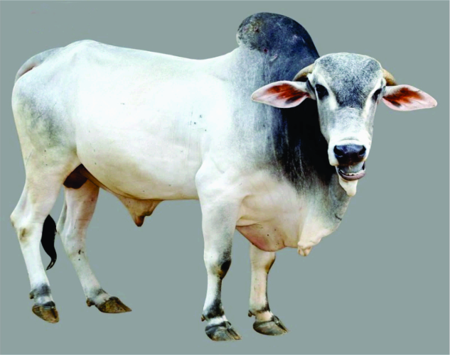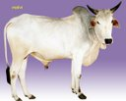

**Malvi Gualao**

**(Malva region, M.P.) (Chhindwara, Betul M.P.)**

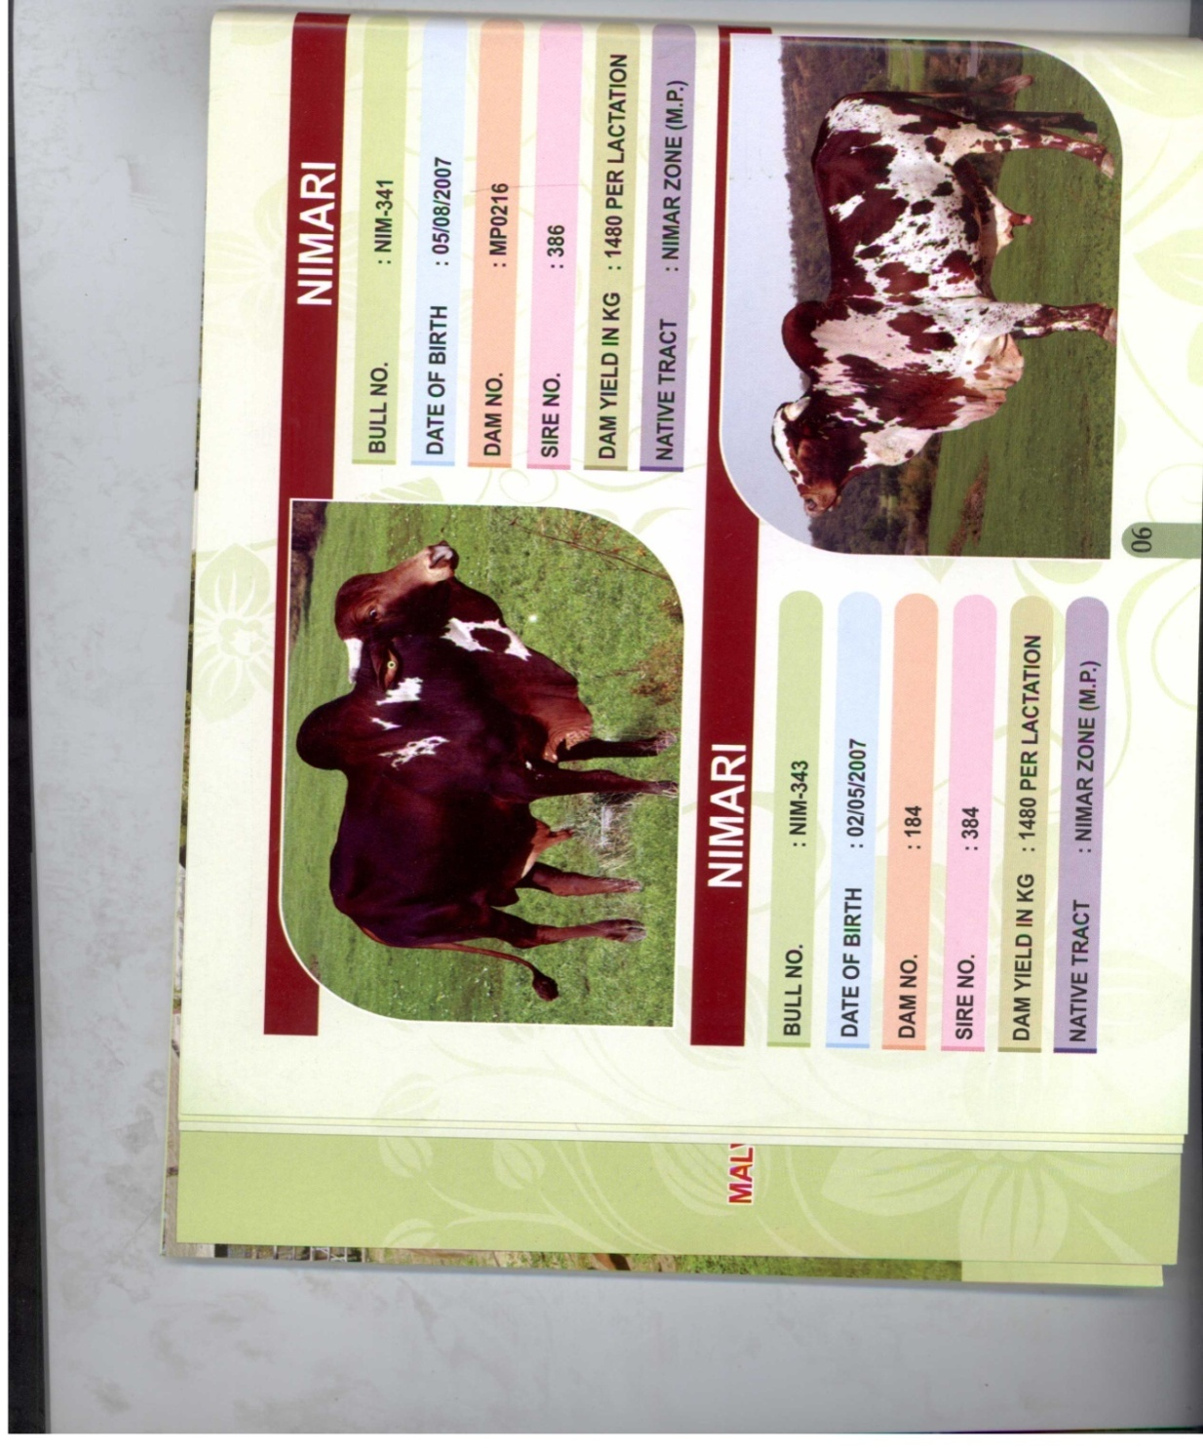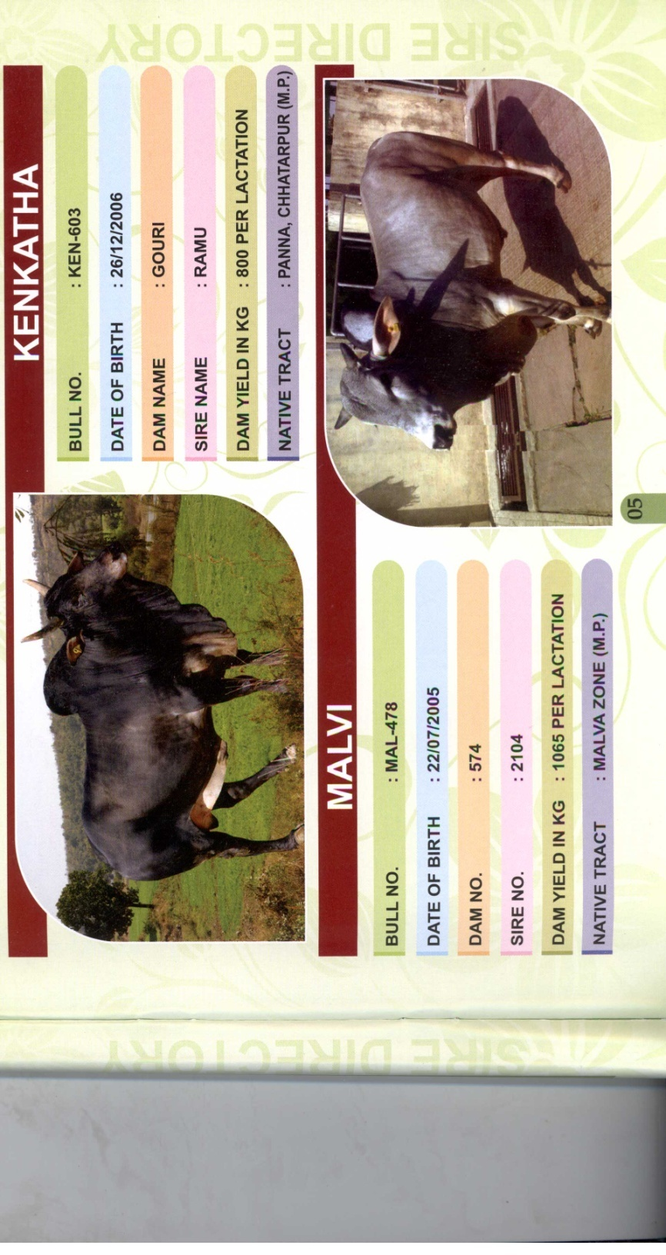

**Nimari Kenkatha**

**(Nimar region, M.P.) (Ken river valley, Panna M.P.)**

**Cow Bulls of Indian Breed**

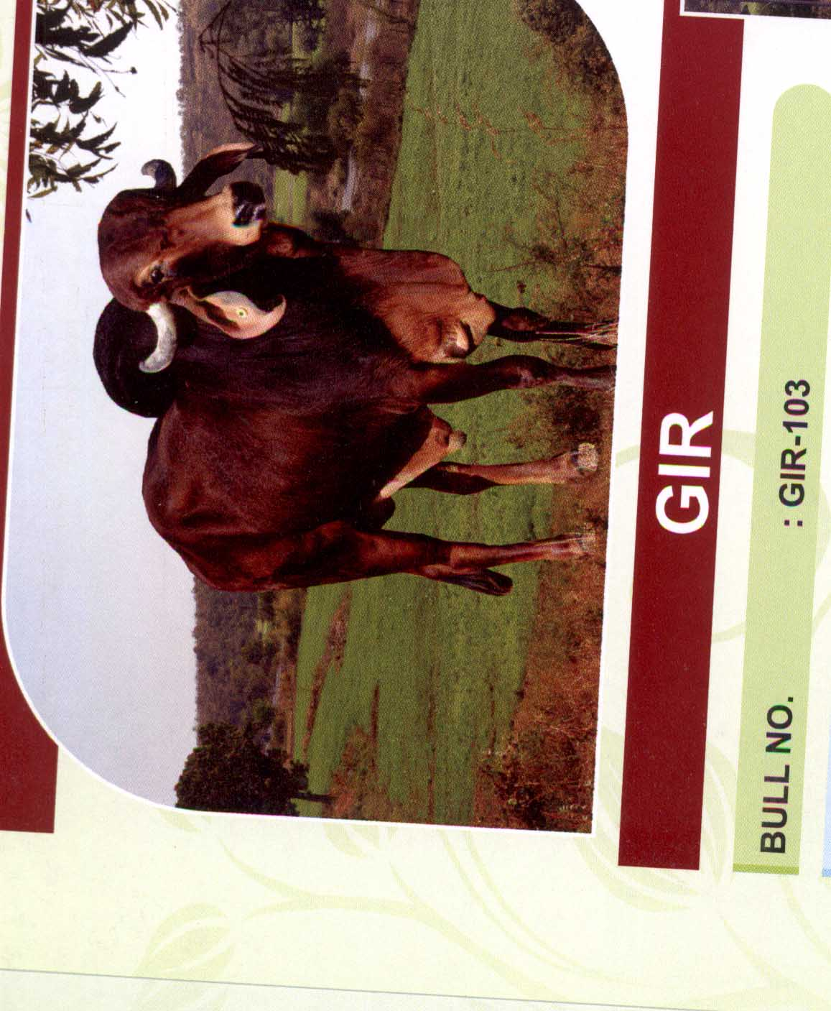

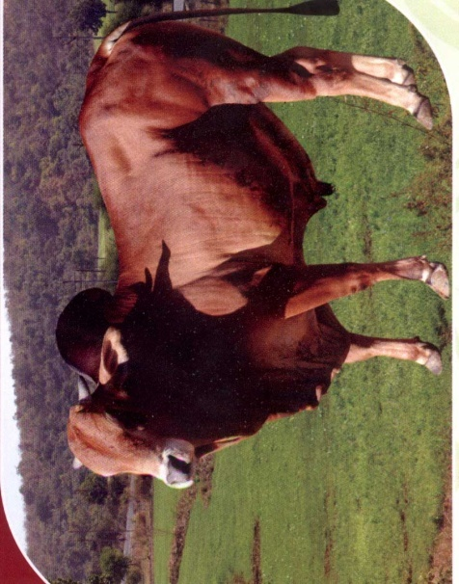

**Sahiwal Gir (Punjab hhindwara, Betul M.P. (Punjab hhindwara, Betul M.P.)**

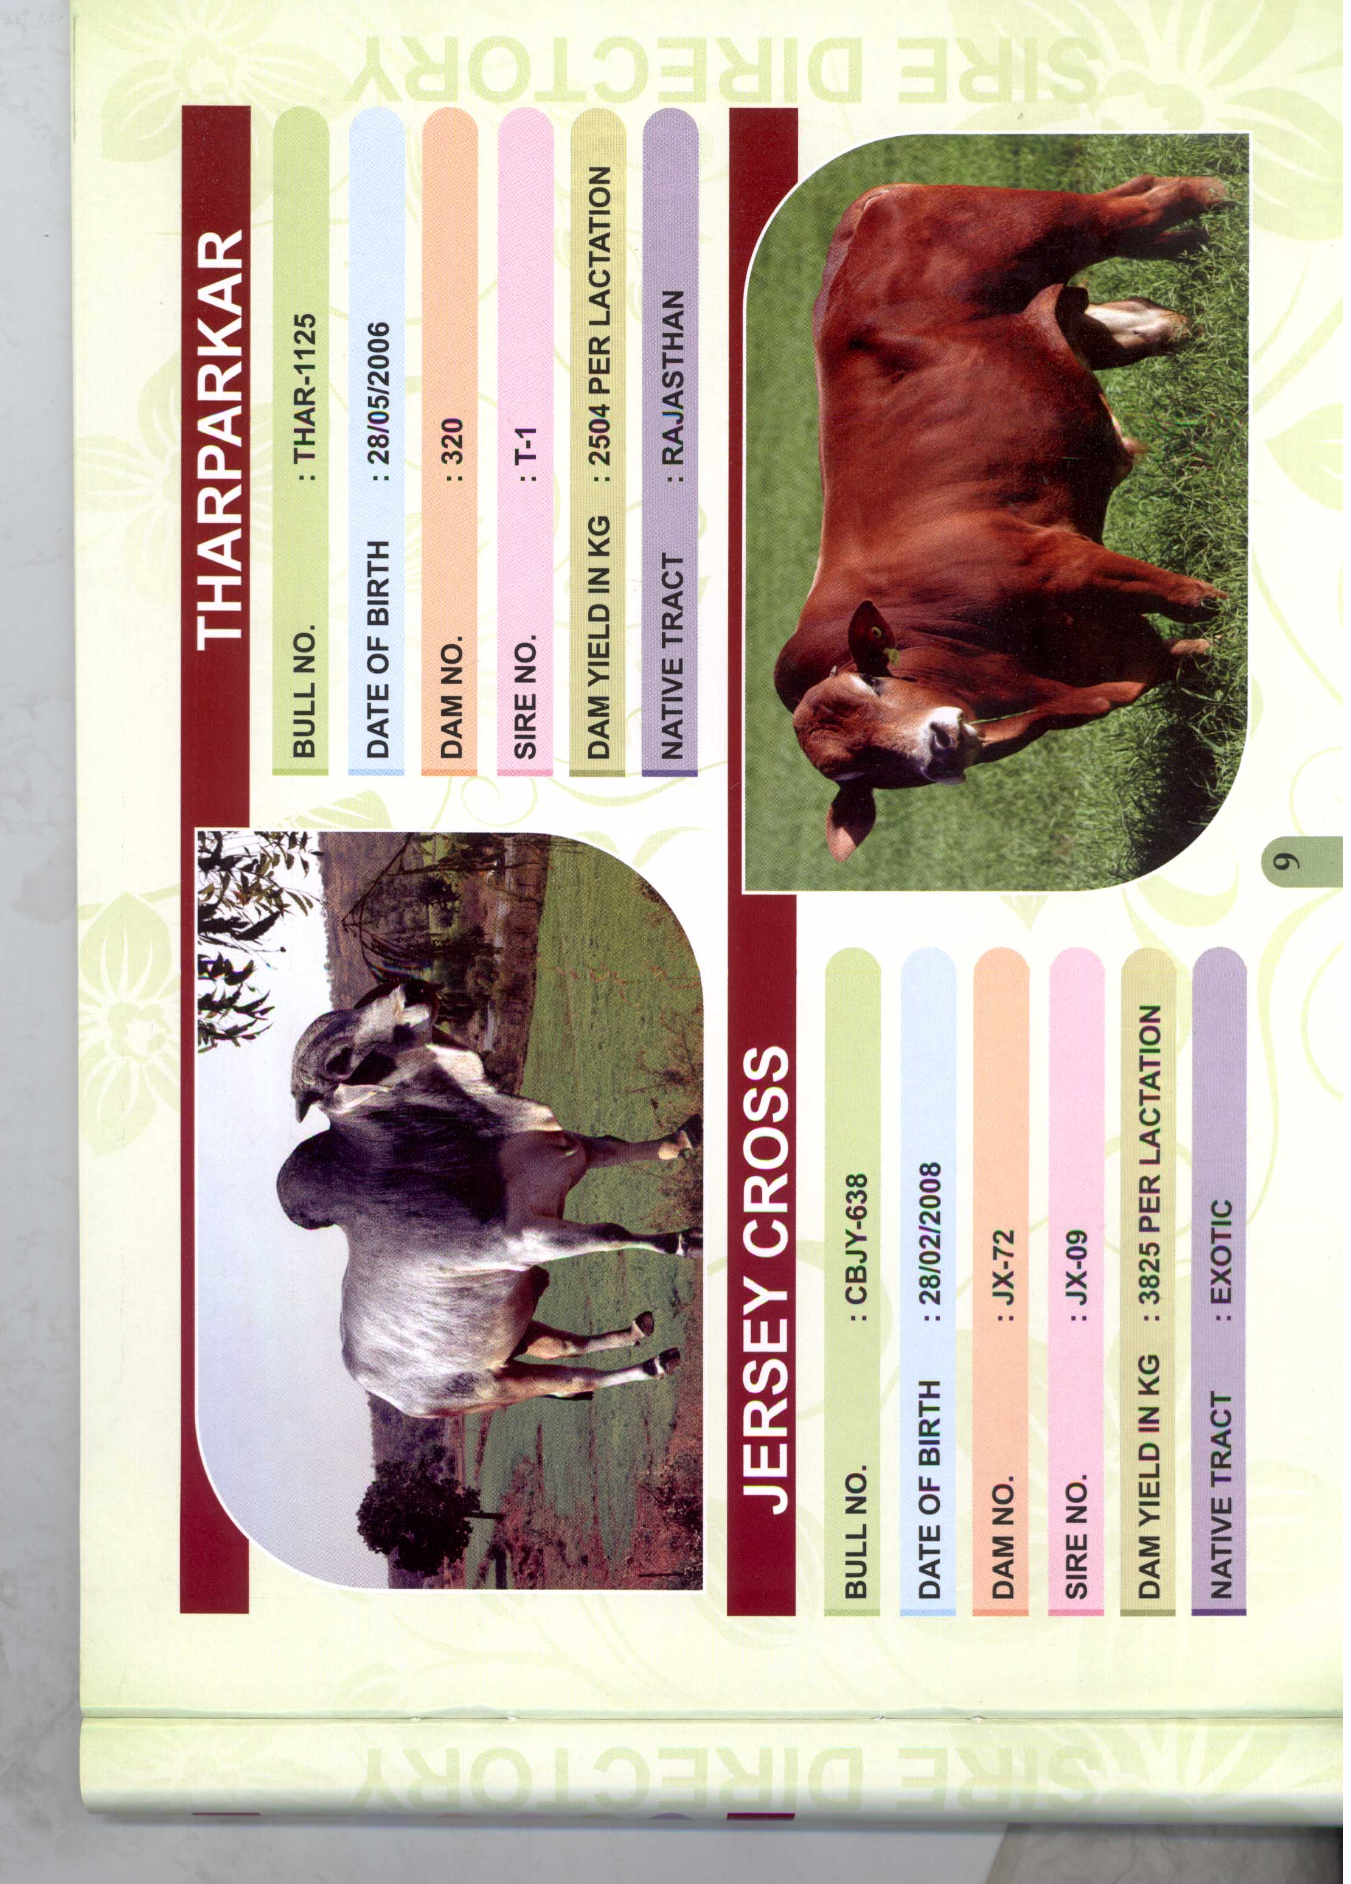

**Tharparkar**

**(Punjab hhindwara, Betul M.P.)**

**Buffaloe Bull of Indian Breed**

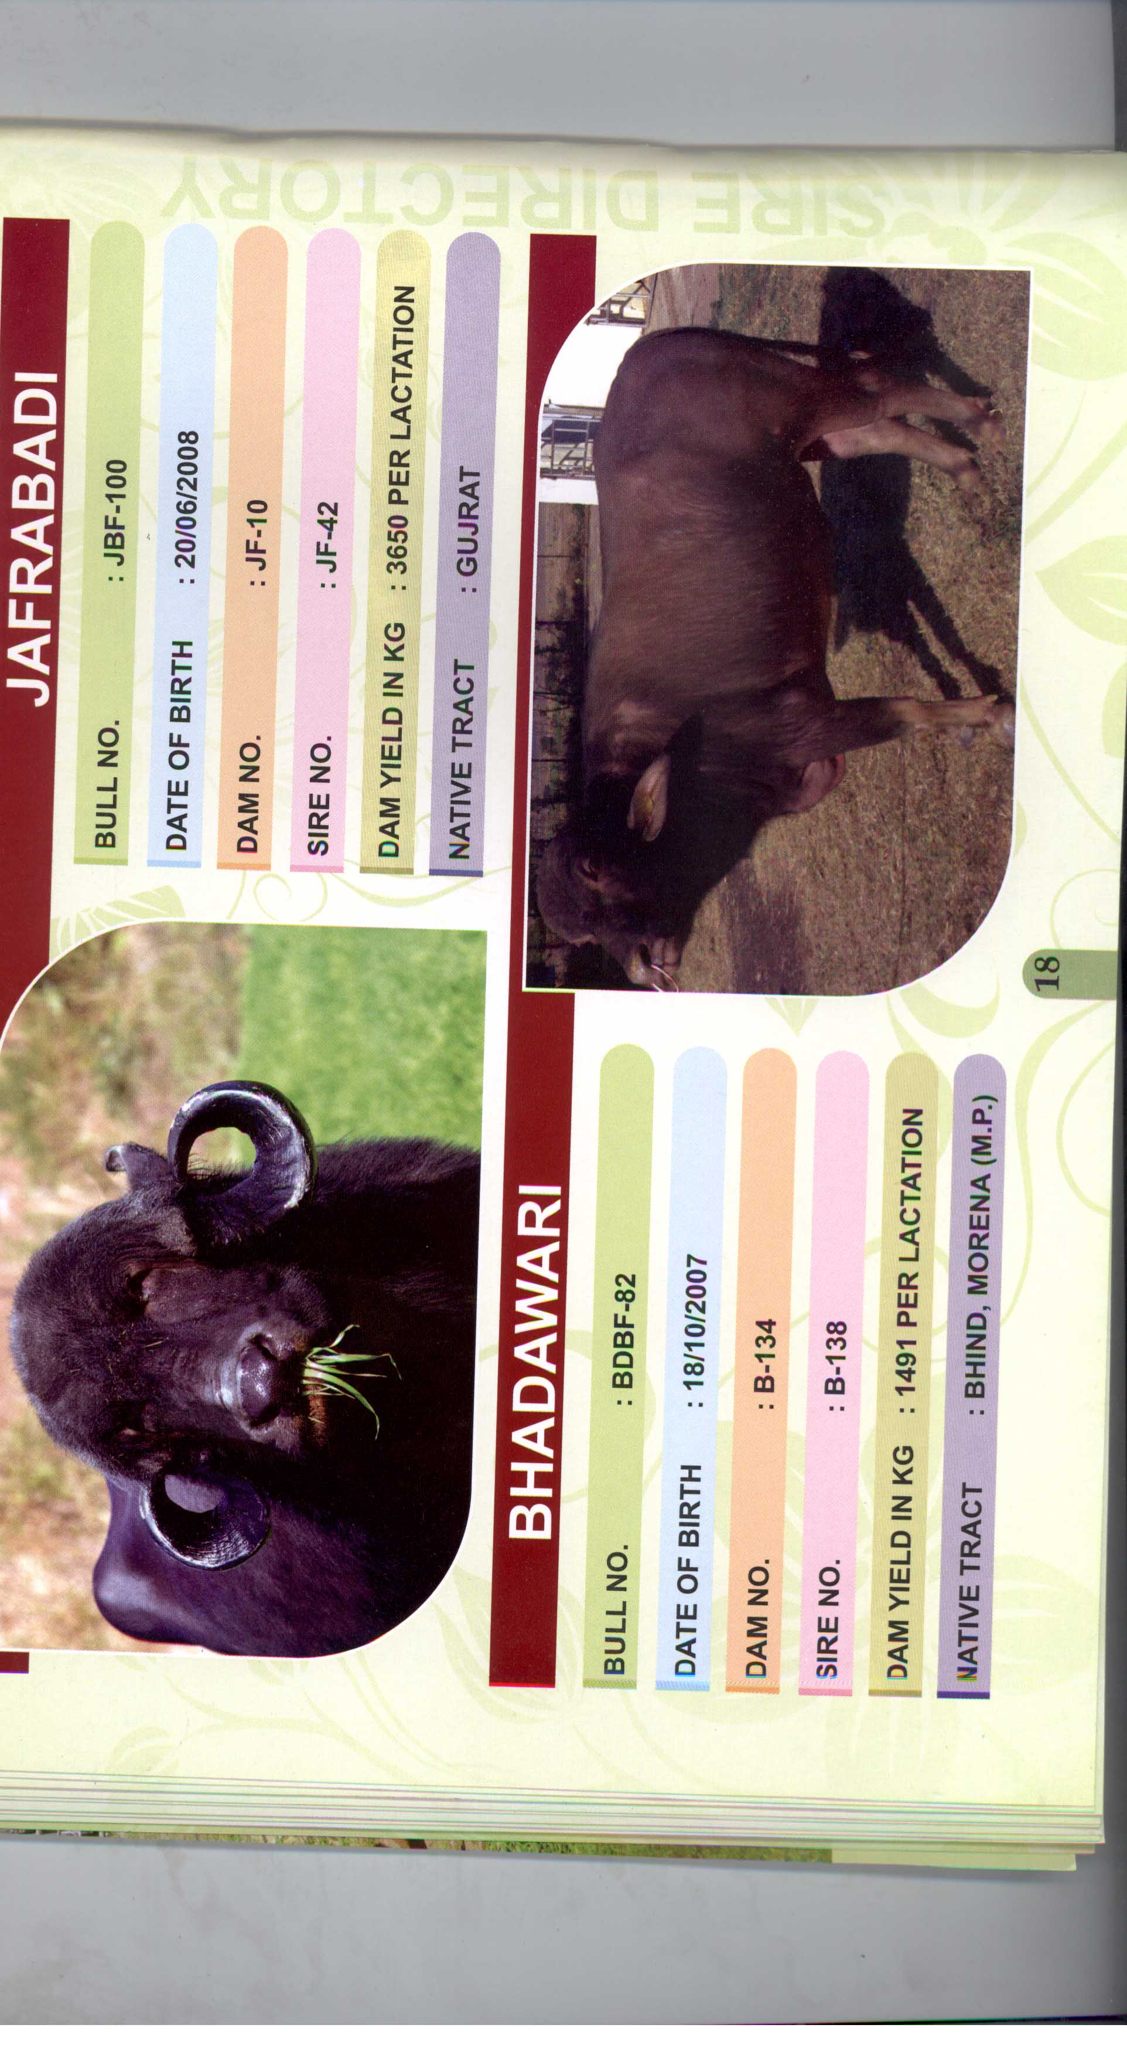

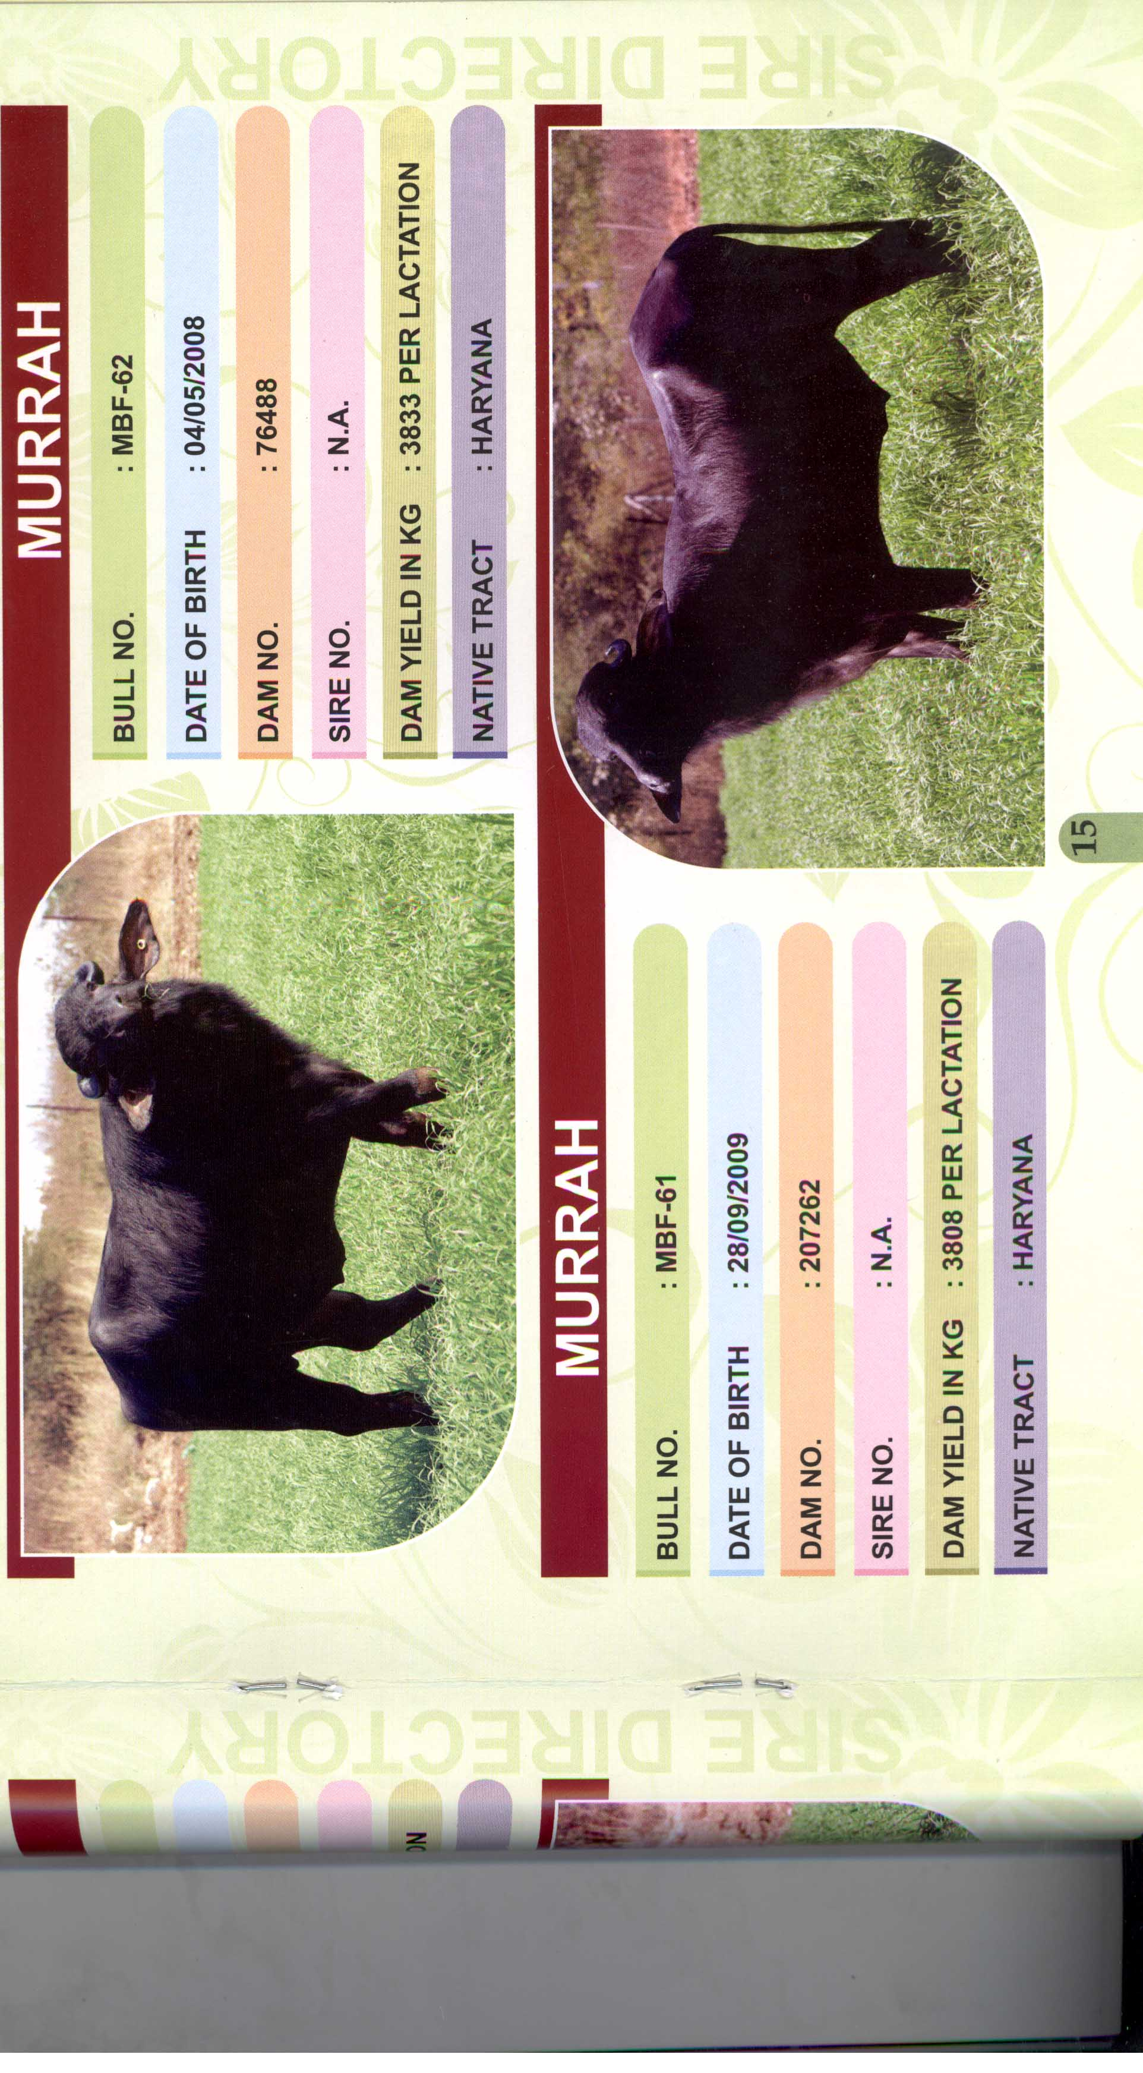

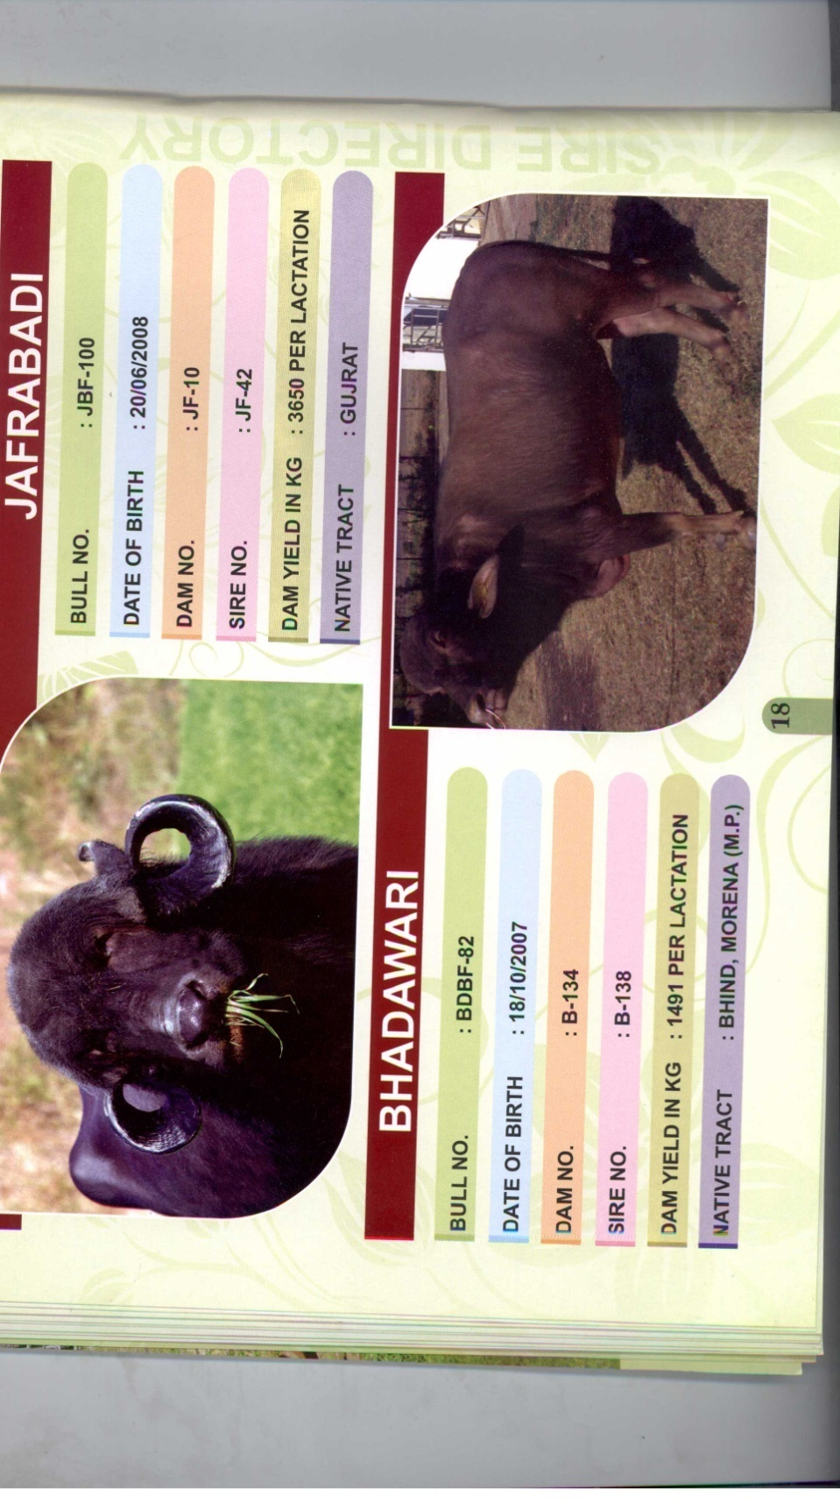 **Murrah Jafrabadi**

**(Hariyana) (Gir forest, Gujrat)**

**Bhadhawari**

**(Madhya Pradesh & Uttar Pradesh)**

**Goats of Indian Breed Reared at**

**Goat Breeding Farm, Kiratpur, Itarsi, District Hoshangabad**

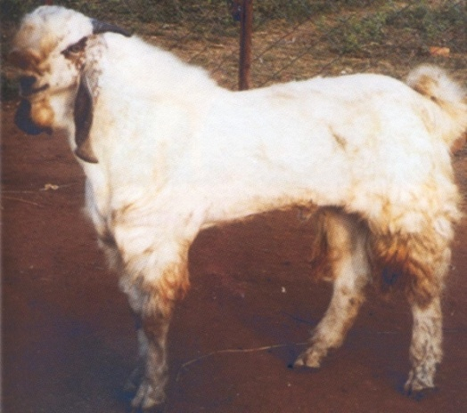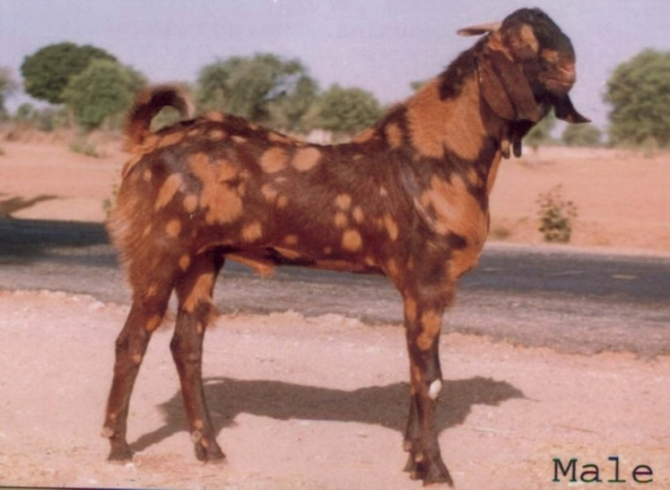

**Sirohi Jamunapari**

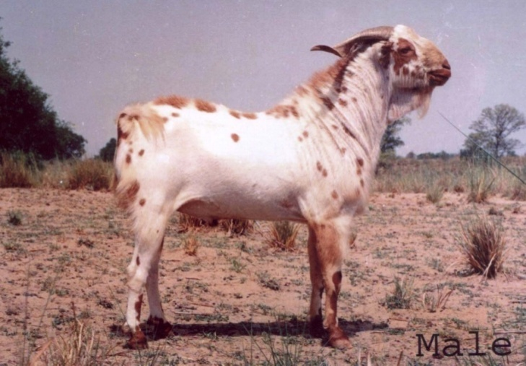**(Sirohi, Ajmer, Pali, Nagor, Rajasthan) (Chambal river valley, M.P.)**

**Barbari**

**(Agra, Mathura, U.P.)**

**Goat Breeding Farm, Kiratpur, Itarsi, District Hoshangabad**

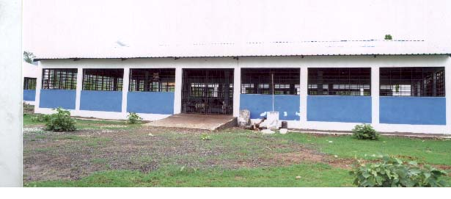

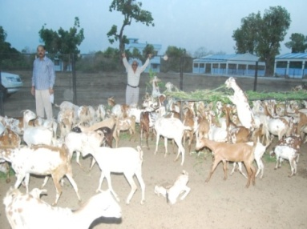

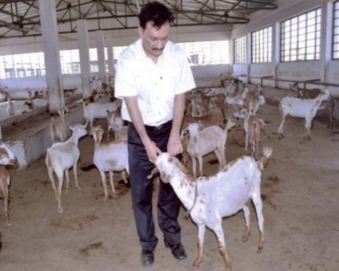

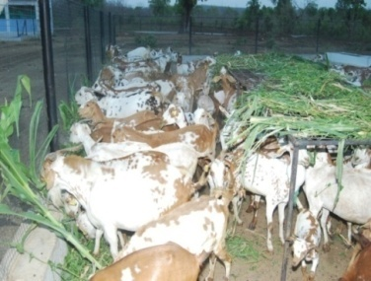

**Visit & Inspection by Principal Secretary, Visit & Inspection by Managing Director**

**Govt. of M.P.,Dept .of Animal Husbandry**

**Goat Breeding Farm, Kiratpur, Itarsi, District Hoshangabad**

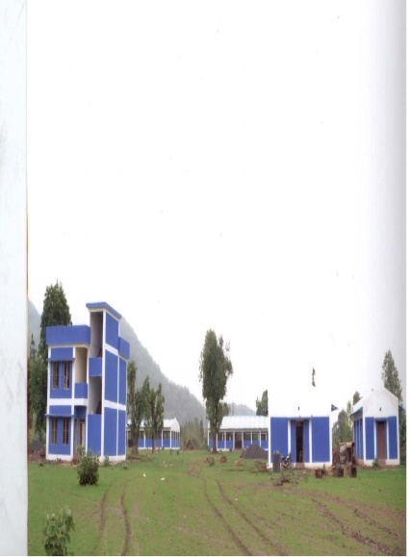

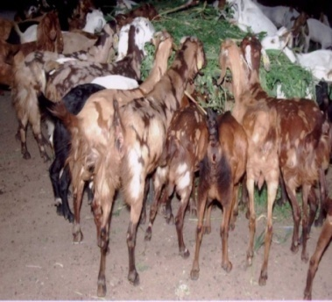

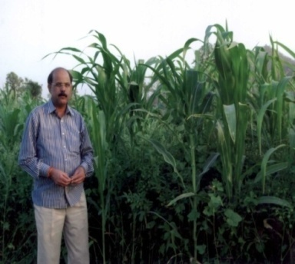

**Production of Green Fodder in Summer Arrangement of Goat Grazing on Iron Stand**

**Season for Goat Breeding**

**(C) Administrative -**

**(Weight age 21)**

|  |  |  |  |  |  |  |  |  |  |  |  |  |  |  |  |  |  |
| --- | --- | --- | --- | --- | --- | --- | --- | --- | --- | --- | --- | --- | --- | --- | --- | --- | --- |
| **S.No.** | **Particular** | **Target**  **2010-11 (`Lakh)** | | **Actual**  **2010-11 (`Lakh)** | | **Target**  **2011-12 (`Lakh)** | | **Actual**  **2011-12 (`Lakh)** | | **Target**  **2012-13 (`Lakh)** | | **Actual**  **2012-13 (`Lakh)** | | **Target**  **2013-14** | | **Corresponding**  **Obj.** | **Weight age** |
| **Phy** | **Fin.**  **(Lakh)** | **Phy** | **Fin.**  **(Lakh)** | **Phy.** | **Fin.**  **(Lakh)** | **Phy.** | **Fin.**  **(Lakh)** | **Phy.** | **Fin.**  **(Lakh)** | **Phy.** | **Fin.**  **(Lakh)** | **Phy** | **Fin.**  **(Lakh)** |
| 1 | Computerization of Activities | Bull Mother Farm, Bhopal for making ISO unit. | 00.50 | Audit completed for ISO Certification | 0.50 | All district information will be computerized | 00.50 | All district information will be computerized | 0.50 | MIS for NPCBB & Cattle Insurance Scheme | 3.00 | Prepared MIS for Cattle Insurance Scheme & NPCBB | 5.00 | MIS will be prepared under NPCBB & Cattle Insurance Schemes for LN2 supply and AI work  All literature especially the information booklets for goat and animal husbandry should be uploaded in Corporation Website | 5.00  3.00 | - | 3 |

|  |  |  |  |  |  |  |  |  |  |  |  |  |  |  |  |  |  |
| --- | --- | --- | --- | --- | --- | --- | --- | --- | --- | --- | --- | --- | --- | --- | --- | --- | --- |
| **S.No.** | **Particular** | **Target**  **2010-11 (`Lakh)** | | **Actual**  **2010-11 (`Lakh)** | | **Target**  **2011-12 (`Lakh)** | | **Actual**  **2011-12 (`Lakh)** | | **Target**  **2012-13 (`Lakh)** | | **Actual**  **2012-13 (`Lakh)** | | **Target**  **2013-14** | | **Corresponding**  **Obj.** | **Weight age** |
| **Phy** | **Fin** | **Phy** | **Fin** | **Phy.** | **Fin** | **Phy.** | **Fin** | **Phy.** | **Fin** | **Phy** | **Fin.** | **Phy** | **Fin** |
| 2 | Automation /  E – Governance | Website of the Corporation make more comprehensive. Address of registered animal suppliers and  Cattle fair information will be available on Corporation website | - | Website of the Corporation made more comprehensive. Address of registered animal supplier and  Cattle fair information entered on Corporation website. |  | i. Corporation web site will be update with all tenders & its norms.  ii. MIS will be developed for beneficiaries complaint and its solution.  iii. Goat unit & Murrah bull supply in Bundelkhand Package will be available on Corporation Website with Barrowers Photo. |  | i. Corporation web site has been updated with all tenders & its norms.  ii. MIS has been developed for beneficiaries complaint and its solution.  iii. Goat unit & Murrah bull supply in Bundelkhand Package has been available on Corporation Website with Barrowers Photo & Photo of animal supply in district cattle fair. | - | i. Corporation web site will be updated with all tenders & its terms & conditions.  ii. MIS will be developed for beneficiaries complaint and its solution.  iii. Goat unit & Murrah bull supply in Bundelkhand Package will be available on Corporation Website with Barrowers Photo. |  | i. Corporation web site has been updated with all tenders & its terms & conditions.  ii. MIS has been developed for beneficiaries complaint and its solution.  iii. Goat unit & Murrah bull supply in Bundelkhand Package has been available on Corporation Website with Barrowers Photo & Photo of animal supply in district cattle fair. |  | i. Corporation web site has been updated with all tenders & its terms & conditions.  ii. MIS has been developed for beneficiaries complaint and its solution.  iii. Goat unit & Murrah bull supply in Bundelkhand Package has been available on Corporation Website with Barrowers Photo & Photo of animal supply in district cattle fair. |  |  | 3 |

|  |  |  |  |  |  |  |  |  |  |  |  |  |  |  |  |  |  |
| --- | --- | --- | --- | --- | --- | --- | --- | --- | --- | --- | --- | --- | --- | --- | --- | --- | --- |
| **SNo** | **Particular** | **Target**  **2010-11 (`Lakh)** | | **Actual**  **2010-11 (`Lakh)** | | **Target**  **2011-12 (`Lakh)** | | **Actual**  **2011-12 (`Lakh)** | | **Target**  **2012-13 (`Lakh)** | | **Actual**  **2012-13 (`Lakh)** | | **Target**  **2013-14** | | **Corresponding Obj.** | **Weight age** |
| **Phy** | **Fin** | **Phy** | **Fin** | **Phy** | **Fin** | **Phy** | **Fin** | **Phy** | **Fin** | **Phy** | **Fin** | **Phy** | **Fin** |
| 3 | Training Building of Employees | 20 | 5.00 | 20 | 5.00 | 20 | 5.00 | 10 | 2.50 | 10 | 2.50 | 7 | 2.80 | 15 | 5.00 | - | 1 |
| 4 | Social Audit/ inspection of Corporation branches | - | - | - | - | Roster will be completed 75% of its target | - | Roster has  been completed 70% of its target | - | Roster will be completed 75% of its target | - | Roster has been completed 75% of its target |  | Roster will be completed 75% of its target |  | - | 2 |
| 5 | Consumer Satisfaction Measures | 1. Quality test of Frozen Semen in village by Vety. College Mhow  2. 3 Meeting of farmers with Bankers & NABARD  3. Meeting of consultative group should be held every 4 months and suggestion and action taken has been recorded. | 0.50 | 1. Quality test of Frozen Semen in village by Vety. College Mhow  2. 3 Meeting of farmers with Bankers & NABARD.  3. Meeting of consultative group should be held every 4 months and suggestion and action taken has been recorded. | 0.50 | - | - | - | - | i. Agri summit  ii. Cattle Insurance Scheme  iii. NABARD Meeting |  | i.3 Agri summit  ii. 2 Cattle Insurance Scheme meeting  iii. 2 NABARD Meeting | 2.00  2.00  2.00 | 1. Quality test of Frozen Semen in village by Vety. College Mhow  2. 3 Meeting of farmers with Bankers & NABARD.  3. Meeting of consultative group should be held every 4 months and suggestion and action taken has been recorded. | 2.00  4.00  2.00 |  |  |

|  |  |  |  |  |  |  |  |  |  |  |  |  |  |  |  |  |  |
| --- | --- | --- | --- | --- | --- | --- | --- | --- | --- | --- | --- | --- | --- | --- | --- | --- | --- |
| **S.No.** | **Particular** | **Target**  **2010-11 (`Lakh)** | | **Actual**  **2010-11 (`Lakh)** | | **Target**  **2011-12 (`Lakh)** | | **Actual**  **2011-12 (`Lakh)** | | **Target**  **2012-13 (`Lakh)** | | **Actual**  **2012-13 (`Lakh)** | | **Target**  **2013-14** | | **Corresponding Obj.** | **Weight age** |
| **Phy** | **F** | **Phy** | **F** | **Phy** | **F** | **Phy** | **F** | **Phy** | **F** | **Phy** | **F** | **Phy** | **F** |
| 6 | **Accounts** i. Finalization of Accounts ii. Completion of Statutory Audit for the year  iii. Laying the Audited Accounts in Vidhan Sabha for the year. | 2009-10  2009-10  2007-08  2008-09  and  2009-10 |  | Accounts Finalized and Audited Audit report will be Laying Next assembly  Audit Report of 2007-08 was laid on 28.07.10 & year 2008-09 Audit Report laid on 30.10.11 |  | 2010-11  2010-11  Laying the Audited Accounts of the Year 2009-10  & 2010-11 in state assembly |  | Accounts Finalized and Audited Audited Report will be submitted current assembly  Audit Report of 2009-10 was laid on 14-03-12  2010-11 & 2011-12 will be laid during the current session |  | 2011-12  2010-11  Laying the Audited Accounts of the Year 2010-11 & 2011-12  in state assembly |  | 2010-11 completed  &  2011-12 not completed  2010-11 is completed & 2011-12 not completion  Not Done |  | 2011-12 & 2012-13 account will be finalized  Year 2011-12 & 2012-13 Audit Report will be completed  Laying the Audited Accounts of the Years 2010-11  & 2011-12 will be placed in the state assembly of 2013-14 |  |  | 3  3 |

|  |  |  |  |  |  |  |
| --- | --- | --- | --- | --- | --- | --- |
| **6** | **Results after Audited documentation -** | | | | | |
| **S.No.** | **Particulars** | **2009-10** | **2010-11**  **(Actual)** | **2011-12**  **(`Actual)** | **2012-13**  **(provisional /tentative)** | **Weight age (%)** |
| 6.1 | Establishment expenditure vis a vis total expenditure (total expenditure will exclude purchase of Goods/ Services for resale) | 39.90 % | 69.39 % | 76.77% | 45.50 % |  |
| 6.2 | Ratio of establishment expenditure vis a vis turnover | 2.4 % | 7.53 % | 6.22 % | 4.75% |  |
| 6.3 | Net worth | (-) 347.08 | (-) 347.08 | (-) 422.48 | (-) 255.08 |  |
| 6.4 | Net worth return | - | - | - | - |  |
| 6.5 | Net profit/Net worth in % | - | - | - | - |  |
| 6.6 | Gross profit / Capital employed | 320.02 | 156.89 | 223.15 | 410.00 |  |
| 6.7 | Debt equity Ratio | - | - | - | - |  |
| 6.8 | Reserved / surplus | 31.80 | 35.00 | Nil | 50.00 |  |
| 6.9 | Total Fixed assets | 75.00 | 69.81 | 78.05 | 80.00 |  |
| 6.10 | Numbers of Permanent Employees | 39 | 38 | 37 | 36 |  |

|  |  |  |  |  |  |  |  |  |  |  |
| --- | --- | --- | --- | --- | --- | --- | --- | --- | --- | --- |
| **S.No.** | **Particular** | **Target**  **2010-11** | **Actual**  **2010-11** | **Target**  **2011-12** | **Actual**  **2011-12** | **Target**  **2012-13** | **Actual**  **2012-13** | **Target**  **2013-14** | **Corresponding Obj** | **Weight age** |
| **Phy.** | **Phy.** | **Phy.** | **Phy.** | **Phy.** | **Phy** | **Phy.** |
| 7 | DPCs | DPC for all promotion will completed | Post of departmental promotion was not vacant | At present Corporation has only one post vacant which is reserved. Corporation will be filled above post when qualified person will be available. | Post of departmental promotion was not vacant | At present Corporation has only one post vacant which is reserved. Corporation will be filled above post when qualified person will be available. | DPC meeting did not held due to unavailability of promotion post | NIL  As no promotional post available |  |  |
| 8 | ACR Completion | All the ACR will be Completed upto  31-03-10 | All the ACR Completed upto  31-03-10 | All the ACR will be Completed upto  31-03-10 | All the ACR Completed upto  31-03-10 | All the ACR will be Completed upto  31-03-11 | All the ACR Completed upto  31-03-11 | All the ACR will be Completed upto  31-03-13 |  | 2 |
| 9 | Departmental Enquiries | All DE will be completed upto 31.03.11 | No DE is pending upto  31-03-11 | All DE will be completed upto 31.03.12 | No DE is pending upto  31-03-12 | All DE will be completed upto 31.03.13 | No DE is pending upto  31-03-13 | All DE will be completed upto 31.03.14 |  |  |
| 10 | Effort to-words appreciation | Best executive officer and best supplier of livestock will be awarded | Not Done | Best executive officer and supplier of livestock will be awarded | Not Done | Best executive officer and supplier of livestock will be awarded | Not Done  6post for ETT sanctioned | 1 accountan assistant  4 Tech. Asstt.  1 stenographer on contract basis to be hired |  | 2 |
| 11 | Staff Rationalization | -  - |  | Staffing pattern will be receiving the finanlized after getting approval from government  - |  | Staffing pattern will be receiving the finanlized after getting approval from government | Action has been taken as per Govt. instruction | Staffing pattern will be receiving the finanlized after getting approval from government |  |  |
| 12 | Advisory committee and publicity | -  - |  | Publicity of Cattle Insurance scheme will be held through Pamphlet, banners and Corporations website.  - |  | Publicity of CIS will be held through Pamphlet, banners and also for cattle supply publicity on Corporations website | Publicity of Cattle Insurance by 1.60 lakh insurance calander, 158707, folder 50000 flex 3000 technical folder & publication of 5000 books on AH | Publicity of Cattle Insurance scheme will be held through calander 1.5 Lakh, folders 50000, 1 documentary film, publication of 3000 books on goat husbandry & 500 sire directory and pemplets 60000 |  | 2 |

**(D) Corporate Governance -**

**(Weight age 5)**

|  |  |  |  |  |  |  |  |  |  |  |  |  |  |  |  |  |  |  |  |  |  |  |  |  |  |  |  |  |  |  |  |  |  |  |  |
| --- | --- | --- | --- | --- | --- | --- | --- | --- | --- | --- | --- | --- | --- | --- | --- | --- | --- | --- | --- | --- | --- | --- | --- | --- | --- | --- | --- | --- | --- | --- | --- | --- | --- | --- | --- |
| **S.No.** | | **Particular** | | **Target**  **2010-11 (`Lakh)** | | | | **Actual**  **2010-11 (`Lakh)** | | | | **Target**  **2011-12 (`Lakh)** | | | **Actual**  **2011-12 (`Lakh)** | | | **Target**  **2012-13**  **(`Lakh)** | | | | **Actual**  **2012-13 (`Lakh)** | | | | **Target**  **2013-14 (`Lakh)** | | | | **Corresponding Obj.** | | | **Weight age** | | |
| **Phy** | | | **F** | **Phy** | | **F** | | **Phy** | **F** | | **Phy** | | **F** | **Phy** | | | **F** | **Phy.** | | | **F** | **Phy** | | | **F** |
| 1 | | No. of Board Meeting in the year (No.) | | 4 | | |  | 1 | |  | | Minimum 4 board meeting will be held in a year |  | | 2 meeting have been done | |  | Minimum 4 board meeting will be held in a year | | |  | 2 meeting have been done | | |  | Minimum 4 board meeting will be held in a year it would be the perusal responsibility of Chairman | | |  | - | | | 1 | | |
| 2 | | Annual General Meeting | | - | | |  | - | |  | | 1 |  | | 1 | |  | 1 | | |  | 1 | | |  | 1 | | |  | - | | |  | | |
| 3 | | Filling of Annual Return (In case of Companies) | | - | | |  | - | |  | | - |  | | - | |  | - | | |  |  | | |  |  | | |  | - | | |  | | |
| 4 | | Filing of Yearly Annual Income Tax Return | | - | | |  | - | |  | | Before  30-09-11 |  | | - | |  | Before  30-09-12 | | |  | - | | |  | Before  30-09-13 | | |  | - | | |  | | |
| 5 | | Filing of yearly provident fund return | | Before  31-10-10 | | |  | Before  31-10-10 | |  | | 30-04-11 |  | |  | |  | 30-04-12 | | |  |  | | |  | 30-04-13 | | |  | - | | | 1 | | |
| 6 | | Filing of Yearly Professional Tax Return | | Before  31-10-11 | | |  | PT filed | |  | | 30-09-11 |  | | 2011-12 | |  | 30.09.12 | | |  |  | | |  | 30.09.13 | | |  | - | | |  | | |
| 7 | | Filing of Half Yearly Service Tax Return | | Before  31-10-11 | | |  | 2010-11 | |  | | April 2011  and  Oct. 2011 |  | | Filed April 2011 & Oct. 2011 | |  | Filing April 2012 & Oct. 2012 | | |  |  | | |  | Filing April 2013 & Oct. 2013 | | |  | - | | |  | | |
| 8 | | Filing of Statutory Returns with ROC | | - | | |  | - | |  | | Before  31-03-12 | - | | Filed before 31-03-12 | |  | Before  31-03-12 | | |  |  | | |  | Before  31-03-13 | | |  | - | | | 1 | | |
| **S.No.** | **Particular** | | **Target**  **2010-11 (`Lakh)** | | | **Actual**  **2010-11 (`Lakh)** | | | | | **Target**  **2011-12**  **(`Lakh)** | | | | | **Actual**  **2011-12 (`Lakh)** | | | | **Target**  **2012-13**  **(`Lakh)** | | | | **Actual**  **2012-13**  **(`Lakh)** | | | | **Target**  **2013-14** | | | | **Corresponding Obj** | | **Weight age** |
| **Phy** | | **F** | **Phy** | | | **F** | | **Phy** | | | **F** | | **Phy** | | | **F** | **Phy** | | | **F** | **Phy** | | | **F** | **Phy** | | | **F** |
| 9 | Transparency Initiatives | | (i) Quarterly updating of Corporation website  .(ii) Information of tender also mentioned in the website.  (iii) MOU of 2010-11 on Corporation website  (iv) All activities of Corporation will be on Corporation website | | **-** | (i) Quarterly updating of Corporation website have been done.  .(ii) Information of tender have mentioned in the website  (iii) MOU of 2010-11 has been displayed on Corporation website | | |  | | Enhancement of Corporation website & every second month update the Corporation websit | | |  | | Enhancement of Corporation website & every second month updated the Corporation websit | | |  | Enhancement of Corporation website & every second month update the Corporation websit | | |  | Enhancement of Corporation website & every second month updated the Corporation websit | | |  | Enhancement of Corporation website & every second month update the Corporation websit | | |  |  | |  |
| 10 | Filing Quarterly VAT Return | | July & Oct. 2010  Jan. & Apr. 2011 | | **-** | done on  July & Oct. 2010  Jan. & Apr. 2011 | | |  | | July & Oct. 2011 Jan. & April 2011 | | |  | | done on  July & Oct. 2011  Jan. & Apr. 2012 | | |  | July & Oct. 2012 Jan. & April 2013 | | |  | done on  July & Oct. 2012  Jan. 2013 | | |  | July & Oct. 2013 Jan. & April 2014 | | |  |  | |  |
| 11 | Formulation of Citizen Charters & its Monitoring | | Application received upto 28-02-11 will be disposed | | **-** | Application not received | | |  | | Application received upto 29-02-12 will be disposed | | |  | | Application received upto 29-02-12 was disposed | | |  | Application received upto 28-02-13 will be disposed | | |  | received application have been disposed | | |  | Application received upto 28-02-14 will be disposed | | |  |  | | 1 |

|  |  |  |  |  |  |  |  |  |  |  |  |  |  |  |  |  |  |
| --- | --- | --- | --- | --- | --- | --- | --- | --- | --- | --- | --- | --- | --- | --- | --- | --- | --- |
| **S.No.** | **Particular** | **Target**  **2010-11 (`Lakh)** | | **Actual**  **2010-11**  **(`Lakh)** | | **Target**  **2011-12**  **(`Lakh)** | | **Actual**  **2011-12**  **(`Lakh)** | | **Target**  **2012-13**  **(`Lakh)** | | **Actual**  **2012-13**  **(`Lakh)** | | **Target**  **2013-14** | | **Corresponding Obj** | **Weight age** |
| **Phy** | **F** | **Phy** | **F** | **Phy** | **F** | **Phy** | **F** | **Phy** | **F** | **Phy** | **F** | **Phy** | **F** |
| 12 | Guaranteeing Right to information through enactment and providing access to the PSU Records | Application received upto 28-02-11 will be disposed | **-** | 15 Application received upto 28-02-11 was disposed |  | Application will be disposed |  | 13 Application received upto 31-03-12 11 was disposed 2 application are pending |  | Application received from 01.03.12 to 31.03.13 will be disposed |  | Received 2 application will be disposed |  | Application received from 01.03.13 to 31.03.14 will be disposed |  |  |  |
| 13 | PSU record information through Right to information |  |  |  |  | Application received upto 29-02-12 will be disposed |  | Application not received upto 29.02.12 |  | Application received upto 28-02-13 will be disposed |  | Disposed application as per rules |  | Application received upto 28-02-14 will be disposed |  |  | 1 |
| **Total** | | | | | | | | | | | | | | | | | **100** |

**Expectations from Government**

1. Require grant-in-aid of R. 5 Cr. from Govt. of M.P. to recoup the fiscal deficit of Corporation.
2. Govt. nominates, private members in Corporation, so grant-in-aid be also given to the Corporation from govt. to meet out their expenditure.
3. Responsibility of animal supply in all Govt. sponsored scheme should be given to Livestock Development Corporation.
4. Central Semen Station, Bhadbhad, Bhopal was transferred to Corporation without Budget, therefore Corporation came under extra financial burden. If suitable Budget transfer is also made to it will help Corporation.
5. It is desirable if all the Poultry, Goatry, Dairy farms be registered through Livestock Development Corporation.

|  |  |  |
| --- | --- | --- |
|  |  |  |
| Managing Director  M.P. State Livestock & Poultry Development Corporation |  | Principal Secretary  Govt. of M.P.  Dept. of A.H. & Dairying |

**M.P. State Livestock & Poultry Development Corporation, Bhopal**

**Memorandum of Understanding Year 2013-14**

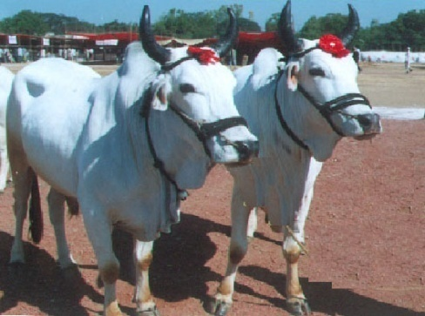

1. Website – www.mplivestock.com
2. E-mail –mplpdcbpl@rediffmail.com